IT24104002

Somarathna J.M.D.D

Lab 04

01)

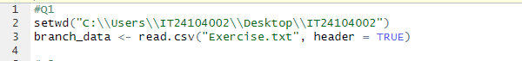

02)

03)

04)

05)

